

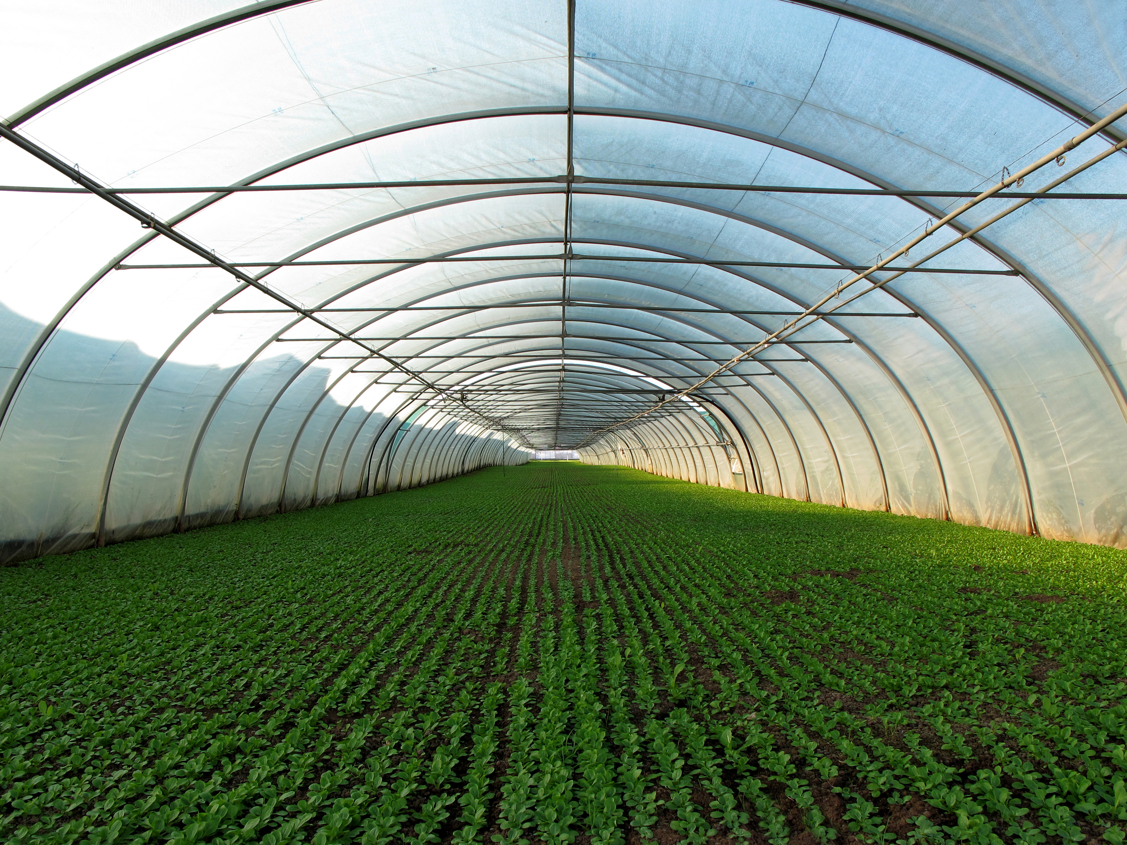

Project proposal for an

Autonomous Greenhouse

Software Engineering for Autonomous Systems

Professor: Davide Di Ruscio

Students:  
Mariama Celi S. de Oliveira - 297854  
Motunrayo Osatohanmen Ibiyo – 297859

# Summary

Goals of the system 2

System Requirements 3

Functional Requirements 3

Non-Functional Requirements 3

MAPE-K Loop Proposal 4

Managed Resources 5

Sensors and the effectors for managed resources 6

Sensors 6

Effectors 7

Autonomic Manager 7

Architectural pattern 7

Adaptation goals 9

Decision Function 9

System of Rules 9

System Architecture 10

References 12

Introduction

A greenhouse is a structure designed to create ideal conditions for plant growth [1]. It is typically constructed from galvanized iron and covered with transparent plastic or glass, allowing natural light to enter. Being a closed environment, a greenhouse enables the control of factors such as temperature, humidity, and carbon dioxide (CO2) levels, which are essential for optimal plant development [2]. As a result, greenhouses are essential tools for promoting plant growth, controlling pests, reducing environmental pollution, and lowering carbon emissions [2]. Therefore, determining the optimal parameters for operating a greenhouse is crucial for efficiently using resources such as energy, land, and water [2].

Considering this context, we propose an automated greenhouse system designed to sustain and regulate the greenhouse environment, optimizing conditions for crop growth in a sustainable manner. The proposal is structured into six sections. The first sections, *System Goals* and *System Requirements*, outline the main objectives of the proposed system and its functionalities. Following this, in the sections *Managed Resources*, we describe the sensors and devices utilized within the environment that directly modify the context. The *Autonomic Manager* section explains the system choices based on a taxonomy. Next, the *MAPE-K Loop* describes the system's behavior according to the MAPE-K loop framework. Finally, the *System Architecture* section provides details about the system components, technologies utilized, and information flows.

By the end of this proposal, we aim to present a comprehensive overview of the automated greenhouse system, ensuring it is detailed and practical enough for implementation.

# Goals of the system

The primary purpose of the automated greenhouse system is to optimize crop growth conditions through autonomous operations. Its main goals are:

* Maintain key variables (**temperature, relative humidity, light, and CO2 concentration**) at appropriate levels for healthy crop development.
* Deploy a flexible solution that is adaptable for more than one crop type.
* Develop an interface where the user can monitor the key variables and resources of the greenhouse.

# System Requirements

To align with the objectives of the system, we have identified both functional and non-functional requirements.

### Functional Requirements

|  |  |  |
| --- | --- | --- |
| ID | Name | Description |
| FR-01 | Real-Time Environmental Monitoring | The system must continuously monitor greenhouse variables, including temperature, humidity, CO₂ concentration, and light intensity, using sensors that transmit real-time data to the system and send it to the Knowledge module. |
| FR-02 | Managed Resource Control | The system must control managed resources, such as fans, heaters, motorized hatches, water pumps, LED lights, and CO₂ injectors, to maintain optimal environmental conditions for plant growth. |
| FR-03 | Crop-Type Adaptability | The system must support multiple crop types by allowing users to select the crop type through a file or UI. The system must adjust environmental thresholds accordingly. |
| FR-04 | Real-Time Data Visualization | The system must provide a user dashboard that displays real-time greenhouse data, including temperature, humidity, CO₂ levels, and light intensity, alongside the current status of managed resources. |
| FR-05 | Historical Data Access | The dashboard must allow users to view historical environmental data for analysis and monitoring purposes. |
| FR-06 | Predictive Analysis | The system must predict future values for temperature, humidity, and CO₂ to act proactively. |

### Non-Functional Requirements

|  |  |  |
| --- | --- | --- |
| ID | Name | Description |
| NFR-01 | Scalable Architecture | The system must be scalable, allowing integration of additional sensors, actuators, or greenhouses without significant architectural modifications. |
| NFR-02 | Maintainable Microservice Design | The system must adopt a modular microservice architecture to ensure maintainability, enabling independent updates, replacements, or improvements to each service without affecting the entire system. |
| NFR-03 | Threshold Flexibility for Crop Types | The system must allow flexibility for different crop types, ensuring that threshold values for environmental variables can be easily adjusted based on user requirements. |
| NFR-04 | Platform Compatibility | The system must be compatible with standard hardware and software platforms, ensuring smooth deployment and accessibility. |

# MAPE-K Loop Proposal

#### The proposed system will implement the MAPE-K Loop framework to automate the process, as it provides a systematic and structured approach to implementing the system. Each element of the MAPE-K Loop will be detailed further below.

#### Monitor

The monitor component is responsible for collecting and processing data from the managed resources. In our system, this specifically involves gathering environmental variables of interest as well as actuator statuses. The monitored variables include:

* **Environmental Variables**:
  + Temperature
  + Humidity
  + CO₂ levels
  + Light intensity
* **Actuator Status**:  
  The monitor also tracks the operational status of the system's actuators. Below is a list of actuators and their respective states:
  + **Fans**
  + **Heaters**
  + **Motorized Hatches**
  + **Pumps**
  + **LED Lights**
  + **CO₂ Injectors**

The data collected ensures continuous awareness of both the environment and actuator performance, providing the foundation for adaptive decision-making processes within the system.

#### Analyser

The analyser utilizes values from the current state and the predictive model and evaluates the current state based on the predefined thresholds and rules of the adaptation goals. Its task is to determine whether the current values are within acceptable limits and whether the predicted future values will exceed the thresholds.

#### Planner

It will determine the actions needed to achieve the desired environmental conditions. Based on the analysis, the system will then utilize a set of predefined rule-based logic to generate a plan of action. In the action plan, it is identified which actuators need to be activated to return to optimal conditions.

#### Executor

It is the responsibility to carry out the planned actions through actuators. Therefore, the actuator will activate or deactivate the managed resources based on the plan created by the planner.

#### Knowledge

The knowledge contains the knowledge base for the system's operation. It stores information such as historical data on the key variables and threshold values. The knowledge allows the system to react proactively and provides flexibility to adapt to different types of crops.

# Managed Resources

To ensure optimal operation and productivity, the greenhouse system relies on the management of key resources. These resources directly influence critical environmental variables that impact plant growth, such as **temperature**, **humidity**, **light levels**, and **CO2 concentration**. Below, we outline the primary managed resources and the variables they control:

1. **Ventilation -** Ventilation plays a crucial role in controlling **temperature** and **humidity** while indirectly influencing **CO2 levels**. By using fans, the system ensures proper air circulation, which helps maintain a balanced greenhouse environment. However, regulating CO2 levels can be challenging due to the exchange of gases with the outside environment during ventilation.
2. **Heating -** The heating system is responsible for maintaining the desired **temperature** within the greenhouse. As one of the most energy-intensive resources, it ensures that the plants remain within their optimal temperature range, especially during colder periods.
3. **Cooling -** Cooling is achieved by adjusting the hatch to control air inflow and outflow. This directly impacts **temperature** and **humidity**. By fine-tuning the hatch position, the system ensures that the internal environment remains stable during hot weather conditions.
4. **Water Distribution -** Water distribution is crucial for maintaining **humidity levels**. Automated irrigation systems activate as needed to keep the plants hydrated and ensure optimal growth conditions without overusing water resources.
5. **Lighting -** LED lighting systems are employed to provide consistent light exposure during the night. This directly affects **light levels**, which are critical for photosynthesis and plant development. By ensuring the necessary amount of light, the system enhances crop growth efficiency.
6. **CO2 Enrichment -** Controlled CO2 injection enhances the photosynthesis process, promoting healthy plant growth. Maintaining optimal **CO2 concentration** is vital, as excessive CO2 levels can pose risks to farmers.

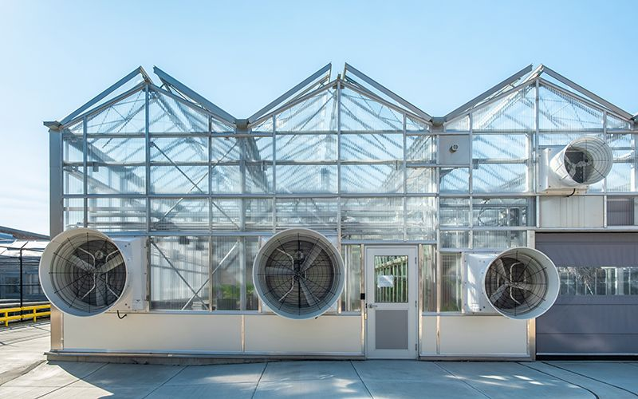

Figure 1- Greenhouse lateral view. The ceiling features hatches at the top and fans at the bottom.

By managing these resources, the system creates an environment where key variables are optimized, ensuring healthy and sustainable plant growth while minimizing resource wastage.

## Sensors and the effectors for managed resources

### Sensors

To be able to appropriately control the managed resources is necessary to measure the variables desired to be controlled. The sensor list includes:

* Temperature sensors (to monitor air temperature);
* Humidity sensors (to measure air moisture levels);
* CO2 sensors (to track carbon dioxide concentration);
* Light intensity sensors (to measure available natural light levels).

### Effectors

These are the devices used to act upon the environment to manage the resources:

* Fans (to control air circulation and ventilation)
* Heaters (to increase temperature as needed)
* Motorized hatches (to open or close ventilation openings)
* Pumps (to distribute water through irrigation systems)
* LED lights (to provide artificial light during low natural light conditions)
* CO2 injectors (to release carbon dioxide into the greenhouse)

## **Autonomic Manager**

The developed system was structured based on the taxonomy illustrated in Figure 2. This section will explore the characteristics of the autonomic manager according to this framework.

### Architectural pattern

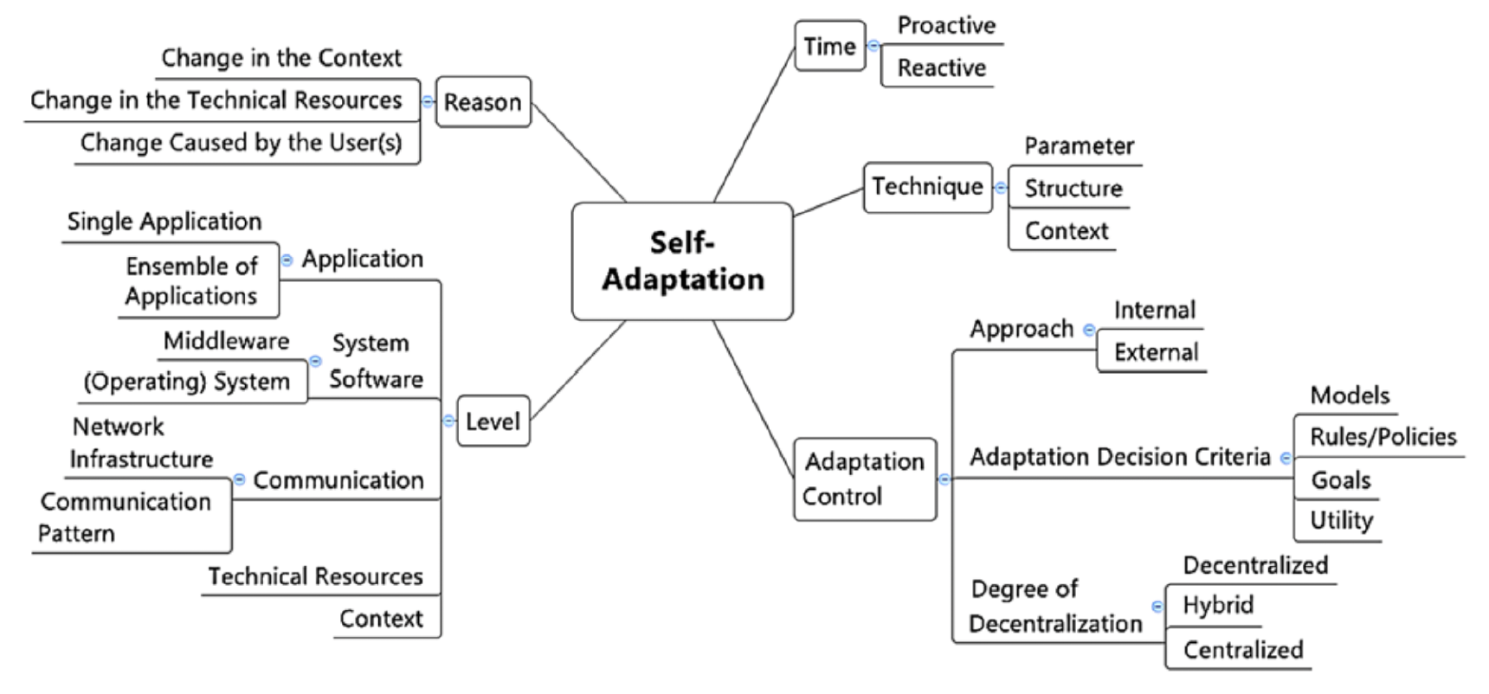

Figure 2 - System Taxonomy

#### Time

**Proactive and Reactive** – Depending on the variable to be adapted, the system will act in a proactive or reactive manner. Variables such as temperature, humidity, and CO2 levels, where it is possible to run predictions regarding their future behavior, allow the system to perform the adaptation before critical levels are reached. However, for light levels, the system will detect when daylight is over to activate the artificial lights.

**Continuous monitoring** – The monitoring will be constant regardless of the variable values.

#### Reason

**Change in the Context** – Adaptation is necessary due to changes in key variables—temperature, relative humidity, light, and CO2 concentration—to prevent any of them from exceeding expected ranges or behaviors.

**Change Cause by the User(s)** – Adaptation can also occur due change in the type of crop selected by the user. Each crop requires a different threshold for the key variables.

#### Technique

**Context Adaptation** – The system keeps track of the key variables, and when one of them goes out of the expected range, one of the actuators (fans, heaters, hatches, pump, LED lights, and CO2 injector) is activated to modify the context to a desired state.

#### Level

**Application** - ***Ensemble of Applications*** – The solution is deployed in a set of microservices, each responsible for one functionality of the solution. Since each service is specialized, each service can easily be replaced by another if needed.

**Context** – The system responds to changes in the environment to maintain the variables within desirable ranges for optimal crop yield through its actuators.

#### Adaptation Control

**Approach** - ***External Approach*** – The system adaptation is separated from the managed resources. Sensors observe the key variables and send the values to a controlled central system that makes decisions based on the adaptation goals and predictions.

**Adaptation Decision Criteria** – ***Goals*** - The adaptation must happen based on a set of adaptation goals.

**Degree of Decentralization – *Centralized*** - The adaptation control is centralized. In other words, a unique subsystem will be responsible for implementing the adaptation logic based on monitoring the context and resources.

# 

# Adaptation goals

Below are listed the goals that must be achieved by the system. The values highlighted in bold should be configured in a specific file depending on the type of crop monitored.

|  |  |  |
| --- | --- | --- |
| Goal | Description | Evaluation Metric |
| Maintain an ideal temperature range for the crop | The temperature must be between an upper limit and a lower limit. | **Lower value <**  temperature (Co)  **< upper value** |
| Maintain relative humidity levels range for the crop | The humidity must be between an upper limit and a lower limit. | **Lower value <**  humidity %  **< upper value** |
| Provide X hours light exposure to the crop | A source of light must be provided to the crop for at least X hours | Number of hours with light> **X hours** |
| Maintain CO2 levels in a range for the crop | The CO2 levels must be between an upper limit and a lower limit. | **Lower value <**  CO2 value in ppm  **< upper value** |

# Decision Function

The decision-making functionality of the autonomic manager is built on a **rule-based** system. While the system is designed to achieve specific goals, it operates by relying on predefined rules that trigger actions in response to monitored variables, characterizing it as a rule-based approach.

### System of Rules

#### Example Tomato Crop

|  |  |
| --- | --- |
| Variable | Recommended Values |
| Temperature | Optimal range: 18°C to 28°C |
| Relative Humidity | Optimal range: 60% to 80% |
| CO₂ Concentration | Optimal range: 400 ppm to 800 ppm |
| Light Exposure | Minimum daily light requirement: 12-16 hours |

#### Rule-Based Logic for Tomatoes

**Temperature:**

* If the **temperature** exceeds 28°C, activate **cooling systems** (activate fans and open hatches);
* If the **temperature** falls below 26°C, deactivate **cooling systems** (deactivate fans and close hatches);
* If the **temperature** falls below 18°C, activate the **heating system**.
* If the **temperature** exceeds 20°C, deactivate the **heating system**.
* If the **temperature trend** predicts exceeding thresholds in the next hour, proactively trigger cooling or heating. (This is an example of how prediction could be utilized).

**Humidity Control:**

* If the **humidity** drops below 60%, activate **water pumps** to increase humidity. Leave it activated until the humidity increases to 65%.
* If the **humidity** exceeds 80%, ventilation can be activated, activating **fans** and opening **hatches** to reduce moisture levels. Leave it open until it drops below 80%.

**CO₂ Concentration Management:**

* If the **CO₂ concentration** drops below 400 ppm, activate **CO₂ injectors** to enrich the air for 5 minutes.
* If the **CO₂ concentration** exceeds 800 ppm, activate **ventilation** systems (activate fans and open hatches) to exchange air and reduce CO₂ levels for 5 minutes.

**Light Management:**

* If natural **light intensity** is insufficient (e.g., during cloudy days or nighttime), turn on **LED lights** to maintain a minimum light duration of 12-16 hours per day.
* Turn off **LED lights** when natural light levels are sufficient during the day.

# System Architecture

The system architecture is illustrated in Figure 3, showcasing a microservice-based design with each component running in its own Docker container. The main components of the system are as follows:  
  
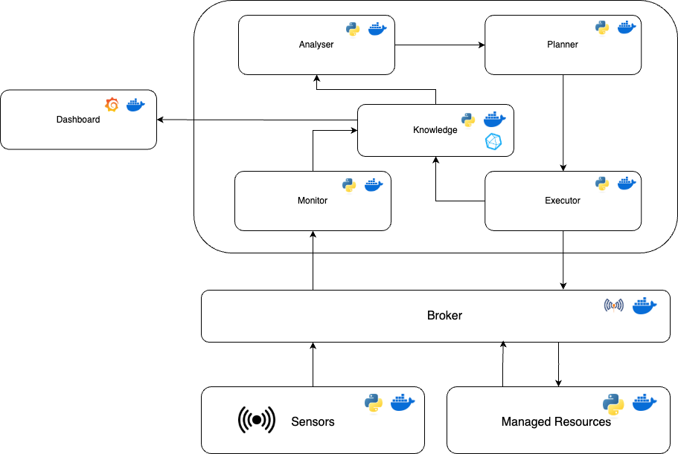

Figure 3 - System Architecture

#### Sensor Service

This service simulates the sensor data for the greenhouse environment. It continuously generates real-time data for key variables such as temperature, humidity, CO2 levels, and light intensity. The simulated data is published asynchronously to a message broker for further processing.

#### Managed Resources

The managed resources service simulates the physical resources inside the greenhouse (e.g., fans, heaters, pumps, motorized hatches, and lights) and their current states. Its key responsibilities include:

* Receiving **action plans** from the broker, which are sent by the **Executor Service**.
* Sending the current state of the resources (e.g., active/inactive, performance metrics) back to the broker, to be monitored and stored in the **Knowledge Service**.

#### Broker

The broker is responsible for managing asynchronous communication between services. It handles:

* Collecting data streams from the **Sensor Service**.
* Forwarding data to the **Monitor Service** for evaluation and storage.
* Transmitting action plans from the **Executor Service** to the **Managed Resources**.

#### MAPE-K Services

The MAPE-K framework defines the flow of the greenhouse system's operation. The **Monitor Service** collects real-time data from sensors and stores it in the **Knowledge Service**. The **Analyzer Service** retrieves both real-time and historical data from the **Knowledge Service** and evaluates the current state against predefined thresholds, incorporating predictions of future states. The results of the analysis are passed to the **Planner Service**, which generates an action plan to address any deviations or anticipated issues. The action plan is then sent to the **Executor Service**, which communicates with the **Broker** to deliver commands to the **Managed Resources**, ensuring that the required adjustments are implemented. This cyclical flow enables the system to adapt dynamically and maintain optimal conditions.

#### Dashboard

The dashboard provides an interface for the user. It is responsible for:

* Displaying the real-time state of the greenhouse variables (e.g., temperature, humidity, light intensity, CO2 levels).
* Showing the current state and activity of the **Managed Resources** (e.g., active fans, water pumps).

The dashboard is built using **Grafana**, which accesses the data from the knowledge base to access its historical data.

# References

[1] Cosman, S. I., Bilatiu, C. A., & Marţiş, C. S. (2019, June). Development of an automated system to monitor and control a greenhouse. In *2019 15th International Conference on Engineering of Modern Electric Systems (EMES)* (pp. 1-4). IEEE.

[2] Li, H., Guo, Y., Zhao, H., Wang, Y., & Chow, D. (2021). Towards automated greenhouse: A state of the art review on greenhouse monitoring methods and technologies based on internet of things. Computers and Electronics in Agriculture, 191, 106558.